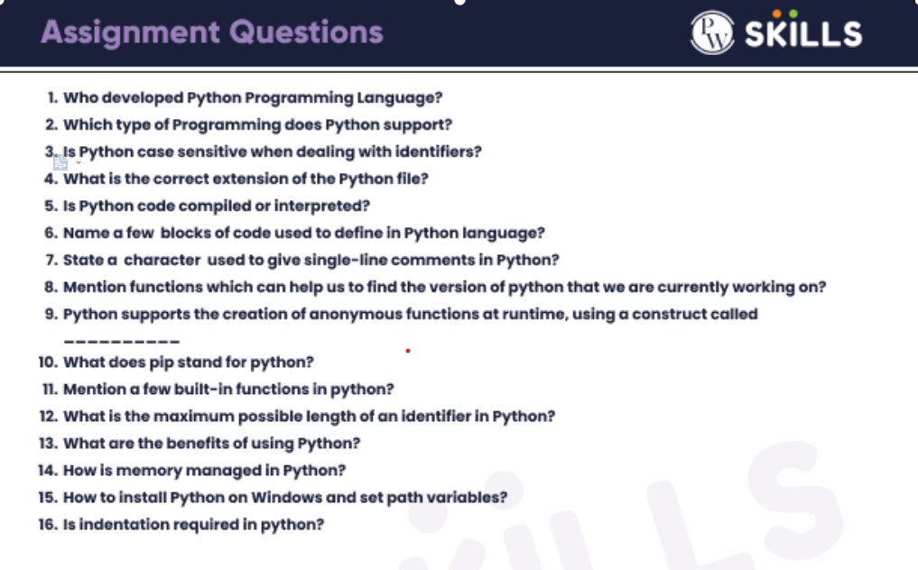**Answer for 29 Jan assignment:**

1. [Guido van Rossum](https://www.google.com/search?rlz=1C1YTUH_enIN1024IN1025&sxsrf=AJOqlzUaybnTxxHj6h-Lt2LkojkwTOxLIQ:1675532959685&q=Guido+van+Rossum&stick=H4sIAAAAAAAAAONgVuLUz9U3MMwwME1-xGjCLfDyxz1hKe1Ja05eY1Tl4grOyC93zSvJLKkUEudig7J4pbi5ELp4FrEKuJdmpuQrlCXmKQTlFxeX5gIACMWaE1cAAAA&sa=X&ved=2ahUKEwiH__vWtvz8AhWcS2wGHbF1A0YQzIcDKAB6BAgMEAE) in 1991.
2. Python supports imperative, functional, procedural, and object-oriented programming.
3. Yes, Python is a case-sensitive language, i.e., it treats uppercase and lowercase characters differently. This applies to identifiers too.
4. (.py)
5. Python is an interpreted language, which means the source code of a Python program is converted into bytecode that is then executed by the Python virtual machine. Python is different from major compiled languages, such as C and C + +, as Python code is not required to be built and linked like code for these languages.
6. A block is a piece of Python program text that is executed as a unit. The following are blocks: a module, a function body, and a class definition. Each command typed interactively is a block.
7. Hash character(#) is used to comment the line in the Python program.
8. Using sys. version method, python_version() function and Python -V command.
9. "lambda"
10. Pip is a recursive acronym that can stand for either "Pip Installs Packages" or "Pip Installs Python".
11. Print() function, type() function, input() function, append() …..etc.
12. An identifier can have a maximum length of 79 characters in Python.
13. **Simple to Use and Understand, Free and Open-Source, Productivity has Increased and Interpreted Language.**
14. As we know, Python uses the dynamic memory allocation which is managed by the Heap data structure. Memory Heap holds the objects and other data structures that will be used in the program. Python memory manager manages the allocation or DE-allocation of the heap memory space through the API functions.
15. In the section entitled User Variables, double-click on the entry that says Path. Another window will pop up showing a list of paths. Click the New button and paste the path to your Python executable there. Once that's inserted, select your newly added path and click the Move Up button until it's at the top.
16. Indentation refers to the spaces at the beginning of a code line. Where in other programming languages the indentation in code is for readability only, the indentation in Python is very important. Python uses indentation to indicate a block of code.